10/MAR/2021
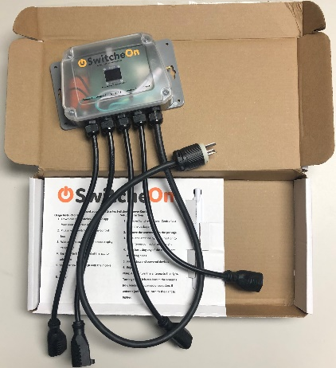
SwitcheOn – 4 channel – 20 amp
Low-cost LTE-M Switch with 4 channels (outlets) and a 20 amp (2400 watt) maximum capacity.

FEATURES

LTE-M Remote power switching
  - Switch 4 Channels (Outlets)
  - Up to 20 amps (2400 watts)
  - Automatic recovery after power failure
Monitoring
  - Ambient temperature sensor
  - Available additional analog/sensor inputs
Bright OLED display
  - Local and ZULU time
  - Cellular Signal status
  - Power/port status
  - Ambient Temperature
Mobile apps for Android and iOS
1st-year service included
- Renews for $50/year on app
Automations for each channel
  - On at Ambient temperature
  - Off at Ambient temperature
  - On at time
  - Off at time
Verizon cell tower based service
  - Uses LTE-M and NB-IoT bands deployed as part of 5G rollouts
  - Newest band type will have long term availability for future
  - Operates much further from cellular towers than normal 3G or 4G
Warranted as long as service is maintained

SPECIFICATIONS
► Operating Voltage: 100-130 VAC @ 50 or 60 Hz
► Current Protection: 20 Amp Capacity main integrated fuse.
► Switching Power: Combined 2400-Watt over 4 Channels. Each channel can have a max of 1800 watts (15 amps)
► Power entry: hard wired 12 AWG (approximately 30 inch), NEMA 5-20P plug Note: Unit can be adapted with P6050 adaptor that de-rates the unit to your hanger’s power capabilities.
► Power outlets: hard wired 14 AWG (approximately 15 inch), NEMA 5-15R receptacle
► Shipped Dimensions: Length: 18.0 in (45.7 cm)
Width: 9.0 in (22.9 cm)
Height: 3 in (7.7 cm)
► Shipped Weight: 4.0 lbs (1.8 kg)
► General Construction: Plastic box
► Antenna: Standard SMA Data, Note: External SMA jack for easy change-over to remote antenna P6045.
► Temperature Range: -40° to 120° F (-40° to 49° C)
► Part number: P6062
What comes with a SwitcheOn
- Ready to use unit
- Box with basic instructions printed to it
- 1 year of Verizon LTE-M service
- Downloadable - User manuals
- Free App (check your app store)

www.preheatremote.com

